【例4-18】feather函数绘图2
>>theta=linspace(0, 2*pi, 20);
>>z = cos(theta)+i*sin(theta);
>>feather(z);
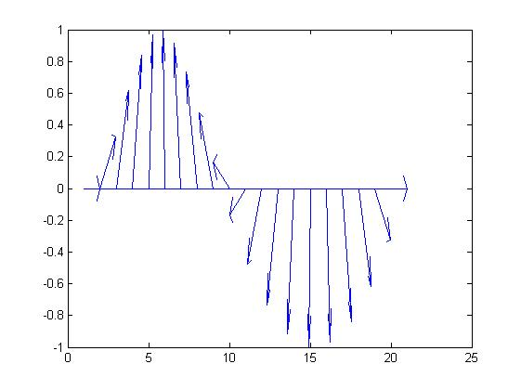
图4-18 feather 函数举例(2)

